

Exhibit 1

Page 1 of 2

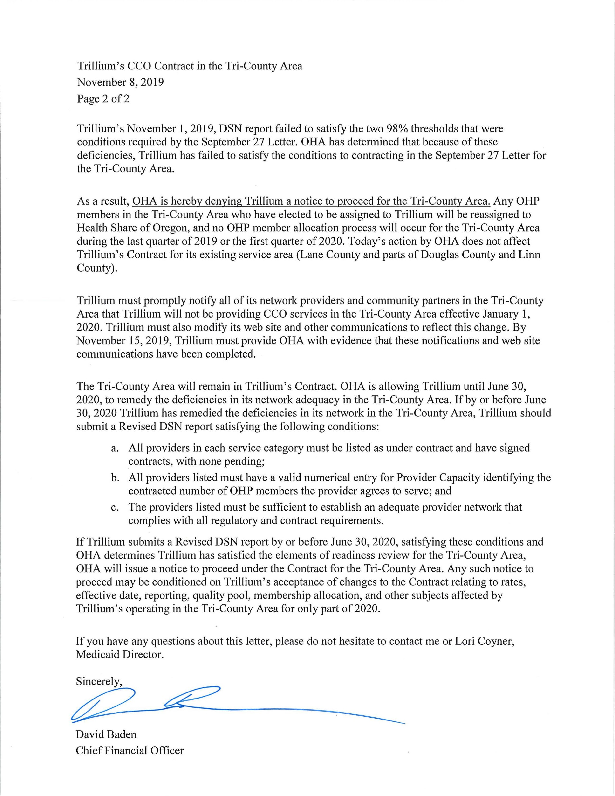

Exhibit 1

Page 2 of 2